What the Lee Health Administrative Fellowship Taught Me That No Degree Ever Could
A life-changing experience that rewired how I see leadership, healthcare, and even myself.

I’ll never forget the day I sat across from Jim Nathan, Lee Health’s former CEO. He began his own journey as an administrative fellow long before leading this organization for more than three decades. Listening to him reflect on the challenges and lessons that shaped him, I thought, “This could be me one day.”

In that moment, the fellowship stopped being just a program. It became something bigger, a legacy I was stepping into.

What the Fellowship Really Is

The administrative fellowship is not an internship. It is a rigorous leadership pipeline where graduates from across the country, including MBAs, MPHs, MHAs, MDs, and PhDs, compete for only a handful of spots. Those who make it rotate across departments, shadow executives, and take on projects that test both skill and resilience.

It is intense, eye-opening, and humbling. It offers the chance to gain hands-on leadership experience, build essential skills, and elevate one’s career to the next level. An administrative fellowship is not just a position; it is a once-in-a-lifetime opportunity that changes you.

Legacy and Revival

Lee Health’s Administrative Fellowship, formerly known as the Administrative Residency, began decades ago. One of its most notable alumni is Jim Nathan, who became a fellow in 1975 before leading the health system through decades of growth from a single hospital, Lee Memorial, to a thriving multi-campus system.

Several early fellows from his era went on to lead hospitals and health systems across the country. The program later paused for several years but was revived under the leadership of Chief People Officer Mike Wukitsch, who believed that cultivating leaders is as vital as caring for patients. His decision reopened the door for a new generation of fellows.

Our Cohort
  Jennifer Sofegha, MBA, MS  2024–2025 Administrative Fellow | 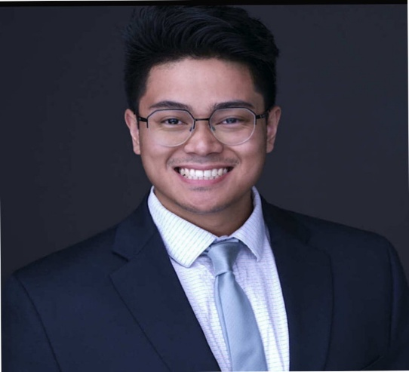  Anton Syvolavong, MHA  2024–2025 Administrative Fellow
After nearly 50 years, Anton Syvolavong and I became the first fellows to walk through that door.

Anton earned a Master of Health Administration from the University of South Florida and brought experience in health administration and patient care, with roles at Tampa General Hospital, Lenstec, and Visionworks. His rotations focused on Equity, Inclusion and Belonging, Patient Safety and Quality, Facilities Management, and Heart Institute Strategy.

I entered as a Certified Medical Manager and Project Management Professional (PMP), with an MBA in Healthcare Management and experience as a Research Assistant and Public Health Specialist at Plateau State Specialist Hospital. My rotations in Health Policy, Information Technology, and Facilities Management deepened my understanding of how systems, strategy, and people intersect to deliver care. Along the way, I worked on projects close to my heart, such as addressing the social factors that influence patient outcomes in the Emergency Department, a reminder that behind every data point is a human story.

Three Lessons I Will Carry for Life

- Leadership: Leadership is the rare balance of trusting others to deliver and disciplining yourself to remain worthy of that trust. True leaders do not carry the whole weight alone; they empower others to rise while holding themselves to the highest standard.

- The System of Care: In the sacred mission of saving lives, no role is lesser. Every job carries the weight of a soul. Healthcare is a system of many parts, and every contribution sustains the whole. When one link weakens, the chain is at risk. When all are honored, lives are safeguarded.

- The Why: Strip away the titles, policies, and buildings, and what remains is the only reason we exist: the patients. That truth anchored me throughout my fellowship, reminding me that every strategy, every budget, and every innovation must serve one purpose, the human being who entrusted us with their health.

Passing the Torch

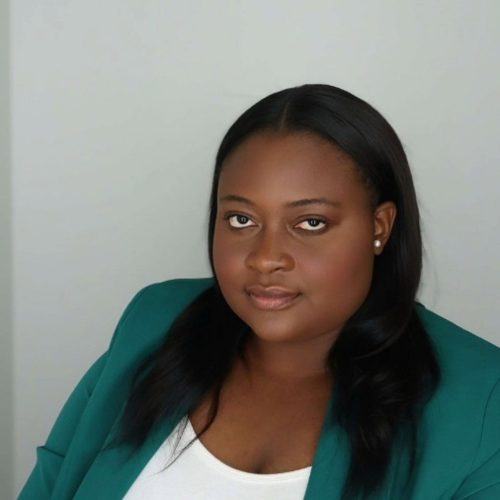  Eunice Mulenda, MBA, MHA  2025–2026 Administrative Fellow | 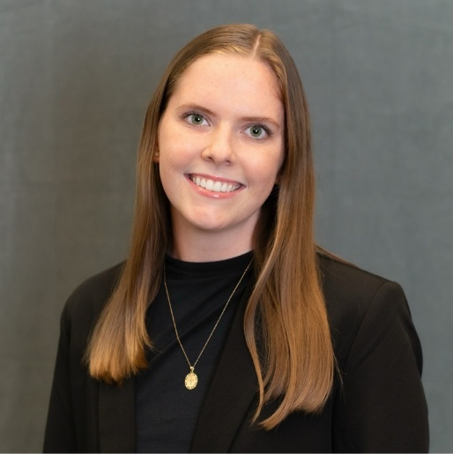  Colleen Mangan, MHA  2025–2026 Administrative Fellow
The journey continues with the 2025–2026 cohort: Eunice Mulenda, who brings a dual MBA/MHA from Georgia State University and a passion for process improvement and operational excellence, and Colleen Mangan, who joins with an MHA from the University of South Florida, a Certified Public Health (CPH) credential, and experience in service line development and finance.

They are already diving into rotations and making their mark. If you see them, do not just wave; stop and say hi. Fellows run on warm welcomes and the occasional coffee tip.

If you or someone you know is interested in applying for the Lee Health Administrative Fellowship, visit Leehealth.org/fellowship for more information and application details.

Gratitude
This journey has been shaped by many remarkable people. To Dr. Larry Antonucci, CEO, for teaching me that great leadership begins with trust, a lesson I will carry throughout my career. To Mike Wukitsch, whose belief in my potential opened this door and changed the trajectory of my path. To Jen Thayer, my fellowship preceptor, whose guidance, patience, and steady presence made even the hardest days lighter. To Michael Nachef, who embodies servant leadership in its purest form, and to Rick Schooler, Dr. Ryan Brown, and Tricia Parker, whose candor and mentorship inspired growth beyond titles. To Anton, my co-fellow and friend, for sharing this journey with grace, humor, and heart. And to every leader and colleague who offered their time, trust, and encouragement, your wisdom has left an imprint I will carry into every room I enter and every project I lead.

This fellowship didn’t just shape my career; it reshaped how I see leadership, purpose, and myself.

“Leadership isn’t just about direction; it’s about self-improvement and the lasting impact you leave behind.”
— Jen Thayer

Jennifer Sofegha, MBA, MS, PMP
2024–2025 Administrative Fellow, Lee Health.

